Introduction

What is a Home SOC Lab?
A Security Operations Center (SOC) Lab is a controlled, isolated, virtualized cybersecurity environment that replicates the monitoring, detection, and intelligence capabilities of an enterprise-grade SOC built entirely on personal hardware. Using VMware Workstation Pro, multiple virtual machines run on a single Windows 11 host with 16 GB RAM, segmented into three independent network subnets.

Why This Lab Was Built
This project was initiated as a solo, self-directed effort to develop hands-on expertise across core cybersecurity domains:
    - Endpoint monitoring and detection using Wazuh SIEM/EDR platform
    - Network intrusion detection using Suricata IDS deployed on pfSense
    - Log analysis and SIEM tool exploration using Splunk Cloud with sample data
    - Threat intelligence management using MISP , custom IOC scenarios created and explored
    - Threat intelligence correlation using OpenCTI integrated with MISP
    - Vulnerable web application hosting via DVWA on Docker
    - Firewall configuration, network segmentation, and routing using pfSense 2.7.x
    - Endpoint telemetry collection using Sysmon on Windows 10

  - Objective
NOTE: To design, install, configure, integrate, and validate a complete Home SOC Lab — deploying SIEM, EDR, IDS, threat intelligence platforms, and log analysis tools within a three-subnet virtualized infrastructure on a single physical Windows 11 host.
IMPORTANT: This is a deployment and configuration report only. It documents installation, network setup, tool configuration, and integration validation. It does NOT cover incident investigation, alert triage, forensic analysis, or SOC operational workflows.

Lab Architecture & Design

2.1 Overview
The Home SOC Lab uses a three-subnet isolation model inside VMware Workstation Pro. pfSense 2.7.x is the central firewall and inter-subnet router. Suricata IDS runs on pfSense in detection mode — generating alerts on identified threats. The SOC Ubuntu VM hosts Wazuh Server, MISP, and OpenCTI together. The Endpoint subnet contains Windows 10 with Sysmon and a manually enrolled Wazuh Agent. The Attack subnet holds Kali Linux and a dedicated Ubuntu VM running DVWA via Docker, also monitored by a Wazuh Agent.

2.2 Subnet Distribution

Subnet | Label | IP Range | VMs / Tools
Subnet 1 | SOC Monitoring | 192.168.10.X/24 | Ubuntu 20.04 , Wazuh 4.x, MISP, OpenCTI
Subnet 2 | User / Endpoint | 192.168.20.X/24 | Windows 10 , Sysmon, Wazuh Agent (manual)
Subnet 3 | Attack & Vuln App | 192.168.30.X/24 | Kali Linux | Ubuntu VM , DVWA + Wazuh Agent
pfSense | Perimeter / Gateway | All subnets | pfSense 2.7.x + Suricata IDS (detection mode)

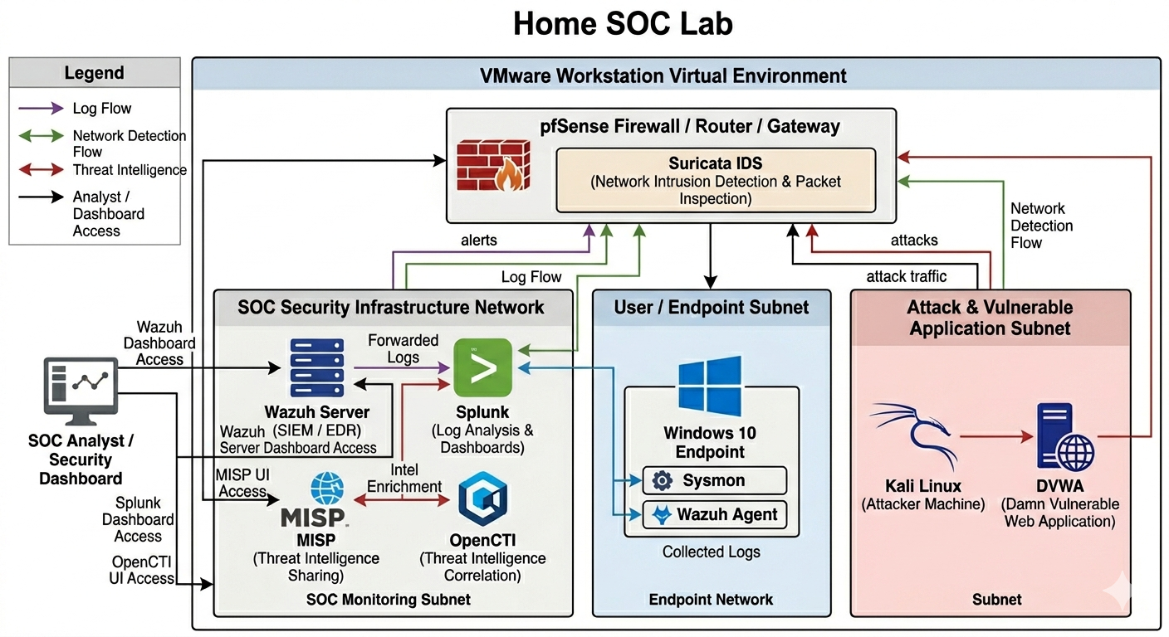

2.3. Data & Detection Flows
- Log / SIEM Flow
Windows 10: Sysmon captures endpoint events, Wazuh Agent (manually enrolled) forwards to Wazuh Server (192.168.10.X).
DVWA Ubuntu VM: Wazuh Agent installed and enrolled forwards Linux system logs. All data visible in Wazuh Dashboard.
- Network Detection Flow
All inter-subnet traffic passes through pfSense, Suricata IDS inspects packets and generates alerts in detection mode and alerts forwarded via syslog (UDP 514) to Wazuh Server.
- Threat Intelligence Flow
Custom threat scenarios and IOC events manually created in MISP , OpenCTI connected to MISP via built-in connector — imported indicators and relationships explored and correlated in OpenCTI.
- Splunk Cloud
Splunk Cloud free trial used for tool exploration. Sample security log files from public GitHub repositories were uploaded. Wazuh live alerts were NOT forwarded to Splunk. Wazuh Dashboard was the primary SIEM interface throughout.

Hardware & Software Requirements
3.1. Host Hardware

Component | Specification | Notes
OS | Windows 11 Pro 64-bit | Physical host
CPU | Intel Core i7 / AMD Ryzen 7 (8 cores) | Intel VT-x / AMD-V must be enabled in BIOS
RAM | 16 GB DDR4 | ~10-12 GB allocated to running VMs
Storage | 512 GB SSD | All VMs consume ~230 GB total
Network | Single NIC | VMware virtual switches handle all internal routing

3.2. Software

Software | Version | Role | Notes
VMware Workstation Pro | 17.x | Virtualization host | On Windows 11 physical host
pfSense CE | 2.7.x | Firewall / Router / Gateway | ISO install
Suricata | Latest (pfSense pkg) | Network IDS — detection mode | pfSense Package Manager
Ubuntu Server | 20.04 LTS | SOC tools host (two VMs) | VM — ISO install
Wazuh | 4.x (latest stable) | SIEM / EDR | Self-hosted all-in-one on Ubuntu 20.04
Splunk | Cloud — Free Trial | Log exploration with sample data | NOT connected to live lab tools
MISP | Latest stable | Threat intel / IOC management | Same Ubuntu 20.04 SOC VM
OpenCTI | Latest stable | Threat intel correlation | Docker Compose — same Ubuntu 20.04 SOC VM
Windows 10 | 21H2+ | Monitored endpoint | VM — ISO install
Sysmon | Latest (Sysinternals) | Endpoint telemetry | Browser download, PowerShell install
Wazuh Agent | 4.x (matches server) | Log forwarding — manually enrolled | MSI on Windows 10 + apt on Ubuntu DVWA VM
Kali Linux | Rolling release | Attacker machine (deployment only) | VM — OVA import from kali.org
DVWA | Latest (Docker) | Vulnerable web app target | Docker on dedicated Ubuntu VM
Docker Engine | Latest | DVWA container runtime | Installed on DVWA Ubuntu VM

3.3. VM Resource Allocation

Virtual Machine | vCPU | RAM | Disk | VMnet
pfSense CE 2.7.x | 1 | 1 GB | 20 GB | NAT + VMnet2 + VMnet3 + VMnet4
Ubuntu 20.04 (Wazuh+MISP+OpenCTI) | 4 | 6 GB | 80 GB | VMnet2 — SOC subnet
Windows 10 Endpoint | 2 | 4 GB | 60 GB | VMnet3 — Endpoint subnet
Ubuntu 20.04 (DVWA+Wazuh Agent) | 1 | 1 GB | 30 GB | VMnet4 — Attack subnet
Kali Linux | 2 | 2 GB | 40 GB | VMnet4 — Attack subnet

Network Topology & IP Scheme

4.1. Subnet Design

Subnet | Purpose | Network | Gateway (pfSense)
Subnet 1 | SOC Monitoring | 192.168.10.X/24 | 192.168.10.1
Subnet 2 | User / Endpoint | 192.168.20.X/24 | 192.168.20.1
Subnet 3 | Attack & Vuln App | 192.168.30.X/24 | 192.168.30.1

4.2. Static IP Assignments

Host | IP Address | Subnet | Role
pfSense-SOC interface | 192.168.10.1 | Subnet 1 | Default gateway
pfSense-Endpoint interface | 192.168.20.1 | Subnet 2 | Default gateway
pfSense-Attack interface | 192.168.30.1 | Subnet 3 | Default gateway
Ubuntu(Wazuh+MISP+OpenCTI) | 192.168.10.X | Subnet 1 | SIEM + Threat Intel server
Windows 10 Endpoint | 192.168.20.X | Subnet 2 | Monitored endpoint
Ubuntu (DVWA+Wazuh Agent) | 192.168.30.X | Subnet 3 | Vuln target + monitored VM
Kali Linux | 192.168.30.X | Subnet 3 | Attacker machine (deployment only)

4.3. VMware Virtual Network Mapping

VMnet | Type | Connected To | Purpose
VMnet0/NAT | NAT | pfSense WAN (em0) | Internet for pfSense + VMs (package installs)
VMnet2 | Host-only | pfSense LAN (em1) + Ubuntu SOC VM | SOC Monitoring subnet
VMnet3 | Host-only | pfSense OPT1 (em2) + Windows 10 | User / Endpoint subnet
VMnet4 | Host-only | pfSense OPT2 (em3) + DVWA VM + Kali | Attack & Vuln App subnet

NOTE: VMs get internet access through pfSense NAT (WAN interface). pfSense WAN (em0) connects to VMware's NAT adapter which provides internet via the host machine's connection. All VMs route internet traffic through pfSense — this is how apt, curl, and wget package downloads worked from inside each VM.

Step-by-Step Deployment Procedure

5.1. VMware Workstation Pro Setup
VMware Workstation Pro 17 was installed on the Windows 11 host. The Virtual Network Editor was configured first to define the three isolated host-only subnets.
Step 1 — Verify Virtualization Enabled
    - Task Manager > Performance > CPU > Virtualization: Enabled
    - If disabled: restart > BIOS/UEFI > enable Intel VT-x or AMD-V

Step 2 — Configure Virtual Network Editor
VMware Workstation → Edit → Virtual Network Editor
Click: Change Settings (requires Administrator)

Add Network: VMnet2  Type: Host-only | Subnet | IP: | 192.168.10.X | / | 255.255.255.0 | | | DHCP: | Disabled
Add Network: VMnet3  Type: Host-only | Subnet | IP: | 192.168.20.X | / | 255.255.255.0 | | | DHCP: | Disabled
Add Network: VMnet4  Type: Host-only | Subnet | IP: | 192.168.30.X | / | 255.255.255.0 | | | DHCP: | Disabled
Click Apply  OK

Step 3 — General VM Creation (applies to all VMs)
    - File > New Virtual Machine > Custom (Advanced) > Next
    - Hardware compatibility: Workstation 17.x > Next
    - 'I will install the operating system later' > Next
    - Select OS type and version > set VM name > Next
    - Assign vCPU and RAM per Section 3.3 > Next
    - Network: 'Do not use a network connection' (configured per VM after creation)
    - SCSI: LSI Logic > Disk type: NVME > Create new disk > set size > Finish
    - Edit VM Settings > assign correct VMnet adapter > mount ISO > Power on

. pfSense 2.7.x Firewall Deployment
pfSense CE 2.7.x was deployed as the central firewall, router, and inter-subnet gateway. It has one WAN (NAT) interface and three LAN interfaces, one per subnet.

Step 1 — Download & Create VM
    - Download pfSense CE 2.7.x ISO.
    - Create VM: 1 vCPU, 1 GB RAM, 20 GB disk — assign 4 network adapters: NAT, VMnet2, VMnet3, VMnet4
    - Mount ISO  boot  follow installer: Accept defaults  Auto UFS  entire disk  reboot
Step 2 — Interface Assignment (Console)
Should VLANs be set up now? [y|n]: n WAN interface: em0 (NAT — internet)
LAN interface: em1 (VMnet2 — SOC subnet) OPT1: em2 (VMnet3 — Endpoint subnet) OPT2: em3 (VMnet4 — Attack subnet) Proceed? [y|n]: y
Step 3 — IP Configuration (Console — Option 2)
LAN (em1): 192.168.10.1 / 24 DHCP server: No OPT1 (em2): 192.168.20.1 / 24 DHCP server: No OPT2 (em3): 192.168.30.1 / 24 DHCP server: No
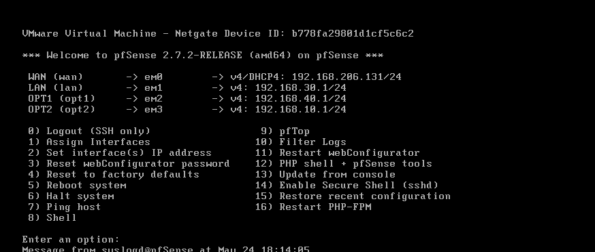
Step 4 — Enable OPT Interfaces via WebGUI
    - Access WebGUI from Ubuntu SOC VM: https://192.168.10.1 — default login: admin / pfsense
    - Interfaces > OPT1 > Enable interface > Description: ENDPOINT > Save > Apply
    - Interfaces > OPT2 > Enable interface > Description: ATTACK >  Save > Apply

Step 5 — Firewall Rules
    - Firewall > Rules > LAN: Add > Pass > Source: any > Dest: any > Save
    - Firewall > Rules > ENDPOINT: Add > Pass > Source: ENDPOINT net > Dest: any > Save
    - Firewall > Rules > ATTACK: Add > Pass > Source: ATTACK net > Dest: any  Save > Apply Changes
NOTE: pfSense adds NO default allow rules for OPT interfaces. Without explicit rules all cross-subnet traffic is silently dropped — a very common issue during initial setup.
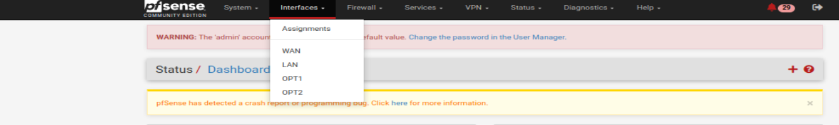
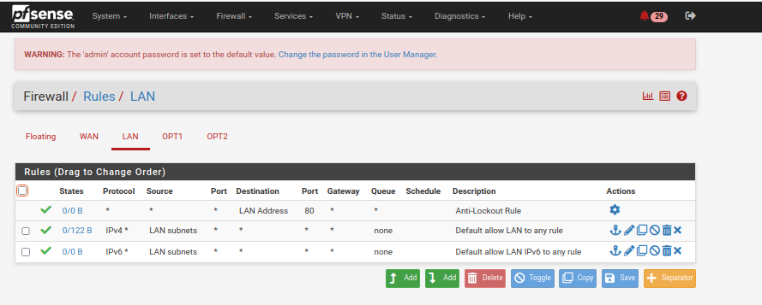
Step 6 — Routing Verification
# From Ubuntu SOC VM (192.168.10.10):
ping 192.168.10.1 # pfSense LAN gateway → Success ping 192.168.20.X # Windows 10 endpoint → Success ping 192.168.30.X # Kali Linux → Success
ping 192.168.30.X # DVWA Ubuntu VM → Success ping 8.8.8.8 # Internet via pfSense NAT → Success

5.3. Subnet Segmentation & Verification

Test | Source VM | Destination | Result
LAN gateway ping | Ubuntu SOC | 192.168.10.1 | Pass
SOC  Endpoint subnet | Ubuntu SOC | 192.168.20.X(Win10) | Pass
SOC  Attack subnet | Ubuntu SOC | 192.168.30.X (Kali) | Pass

Test | Source VM | Destination | Result
SOC  DVWA VM | Ubuntu SOC | 192.168.30.X | Pass
Endpoint  Wazuh server | Windows 10 | 192.168.10.X | Pass
Attack subnet gateway | Kali Linux | 192.168.30.1 | Pass
5.4. Ubuntu 20.04 LTS + Wazuh 4.x Deployment
Ubuntu Server 20.04 LTS was installed on the SOC VM (192.168.10.10) and used to host Wazuh Server, MISP, and OpenCTI together on the same machine to conserve RAM.
Step 1 — Ubuntu Install & Static IP
      - Create VM: 4 vCPU, 6 GB RAM, 80 GB disk > VMnet2
      - Install Ubuntu Server 20.04 LTS > enable OpenSSH server during setup
      - During network configuration — set static IP: 192.168.10.X / 24, Gateway: 192.168.10.1, DNS: 8.8.8.8
Step 2 — System Update
sudo apt update && sudo apt upgrade -y
sudo apt install -y curl wget gnupg2 apt-transport-https
Step 3 — Wazuh 4.x All-in-One Installation
Wazuh was installed using the official automated script with the -a flag, which deploys the Wazuh Manager, Indexer, and Dashboard in a single command — no separate component installs required.

# Download the Wazuh installer:
curl -sO https://packages.wazuh.com/4.x/wazuh-install.sh

# Run all-in-one installation (-a flag = all components):
sudo bash wazuh-install.sh -a

# Installation takes 10-20 minutes
# SAVE the generated admin password — shown once at end of install

NOTE: The -a flag installs all Wazuh components automatically in one step: Wazuh Indexer + Wazuh Manager + Wazuh Dashboard. No separate config.yml editing or step-by-step component installation is required.
Step 4 — Open Required Firewall Ports
sudo ufw allow 443/tcp # Wazuh Dashboard (HTTPS) sudo ufw allow 1514/tcp # Agent communication sudo ufw allow 1515/tcp # Agent registration sudo ufw allow 55000/tcp # Wazuh REST API
sudo ufw enable

Step 5 — Verify Services & Access Dashboard

sudo systemctl status wazuh-manager # active (running) sudo systemctl status wazuh-indexer # active (running) sudo systemctl status wazuh-dashboard # active (running)
# Check version:
/var/ossec/bin/wazuh-control info

    - Browser  https://192.168.10.X accept certificate  login: admin / [generated password]
    - Dashboard loads > Security Events > confirms working

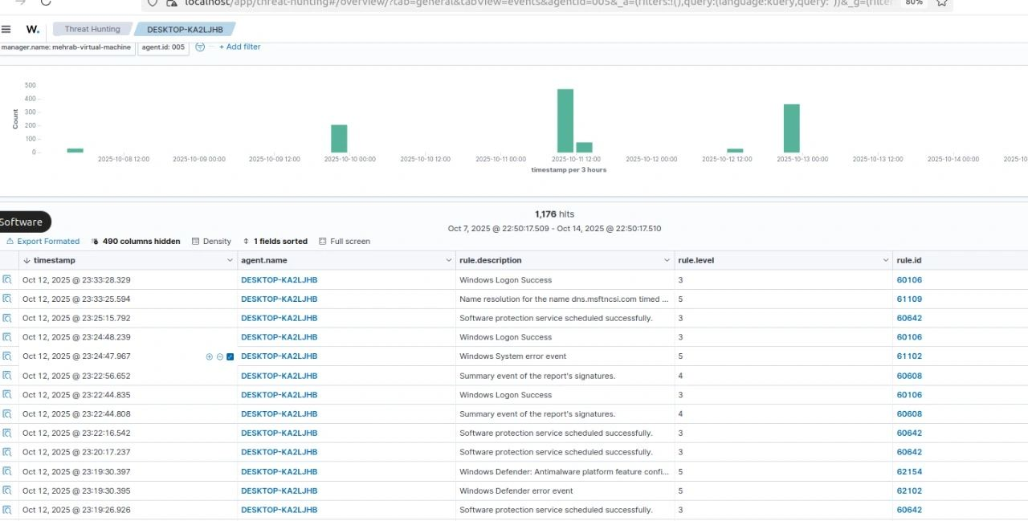

5.5. Windows 10 Endpoint Deployment
Step 1 — VM & OS Install
    - Create VM: 2 vCPU, 4 GB RAM, 60 GB disk  VMnet3
    - Install Windows 10 21H2+ choose local account during setup

Step 2 — Static IP Configuration
Settings → Network & Internet → Ethernet → Change adapter options Right-click adapter → Properties → IPv4 → Properties
IP Address: 192.168.20.X
Subnet Mask: 255.255.255.0
Default Gateway: 192.168.20.1
DNS Server: 8.8.8.8

Step 3 — Connectivity Verification
ping 192.168.20.1 # pfSense Endpoint gateway → Success ping 192.168.10.X # Wazuh Server → Success
ping 8.8.8.8 # Internet via pfSense NAT → Success

5.6. Sysmon Deployment on Windows 10
Sysmon (System Monitor) from Microsoft Sysinternals was installed on Windows 10 to capture high-fidelity endpoint telemetry — process creation, network connections, file creation, and registry events.
Step 1 — Download via Browser
- Open browser go to: https://docs.microsoft.com/enus/sysinternals/downloads/sysmon
- Download Sysmon.zip > extract to C:\Tools\Sysmon\
- Download SwiftOnSecurity config: https://github.com/SwiftOnSecurity/sysmon-config 
- sysmonconfig-export.xml > save to C:\Tools\Sysmon\

Step 2 — Install via PowerShell (Admin)
cd C:\Tools\Sysmon

# Install with SwiftOnSecurity config:
.\Sysmon64.exe -accepteula -i sysmonconfig-export.xml

# Expected output:
# Sysmon64 installed. SysmonDrv installed. Starting Sysmon64.
Step 3 — Verify
Get-Service Sysmon64 # Status: Running

# Event Viewer → Applications and Services Logs # → Microsoft → Windows → Sysmon → Operational
# Events (ID 1, 3, 11...) should appear immediately

Event ID | Captures | Detection Value
1 | Process Creation | New process launches, parent-child chain
3 | Network Connection | Outbound connections — C2 detection
7 | Image Loaded | DLL loads — injection detection
11 | File Created | File drops, malware writes to disk
12 / 13 | Registry Events | Persistence via registry keys
22 | DNS Query | C2 beaconing, DNS tunneling

5.7. Wazuh Agent — Manual Enrollment on Windows 10
The Wazuh Agent was installed on Windows 10 using the MSI installer. The Windows agent was enrolled manually using an authentication key generated on the Wazuh Manager via the manage_agents utility. The key was then entered in the Windows GUI installer.
NOTE: This is Method B — Manual Key Enrollment. The agent does not auto-register. The agent entry and its authentication key are created on the manager first, then the key is provided during installation. This is the more secure and controlled enrollment method.
Step 1 — Generate Agent Key on Wazuh Manager
# On Ubuntu SOC VM:
sudo /var/ossec/bin/manage_agents

# Menu appears — choose options:
(A) Add an agent:
Name: WINDOWS10-ENDPOINT IP: 192.168.20.X
ID: 001 (auto-assigned)
Confirm: y
(E) Extract key for agent: Enter agent ID: 001
KEY IS DISPLAYED — COPY THIS KEY

(Q) Quit
Step 2 — Download & Install Wazuh Agent MSI (Windows 10 Browser)
    - Open browser on Windows 10  go to: https://packages.wazuh.com/4.x/windows/
    - Download latest wazuh-agent-4.x.x-1.msi
    - Double-click .msi > installer opens > Accept license > Next
    - Manager IP field: enter 192.168.10.X
    - Agent Name: WINDOWS10-ENDPOINT
    - Authentication key field: paste the key copied from manage_agents
    - Click Install > wait for completion > Finish

Step 3 — Edit ossec.conf — Add Sysmon & Defender Log Paths
# File: C:\Program Files (x86)\ossec-agent\ossec.conf # Open with Notepad as Administrator — add inside :
Microsoft-Windows-Sysmon/Operational eventchannel

Microsoft-Windows-Windows Defender/Operational eventchannel

Security eventchannel
Step 4 — Start Service & Verify
# PowerShell (Admin):
Start-Service -Name WazuhSvc
Set-Service -Name WazuhSvc -StartupType Automatic

# On Ubuntu SOC VM — verify agent active:
sudo /var/ossec/bin/manage_agents -l
# Expected: ID: 001 Name: WINDOWS10-ENDPOINT Status: Active
    - Wazuh Dashboard  Agents  WINDOWS10-ENDPOINT  Status: Active (green)

5.8. Splunk Cloud Integration
IMPORTANT: Splunk Cloud was used for tool exploration only during the free trial. Live Wazuh alerts were NOT forwarded to Splunk. Sample security log files from public GitHub repositories were uploaded to Splunk Cloud for hands-on learning of SPL queries, indexing, and dashboard creation.
Step 1 — Register for Splunk Cloud Trial
      - Go to: https://www.splunk.com/en_us/download/splunk-cloud-trial.html
      - Register  receive dedicated Splunk Cloud instance URL

Step 2 — Upload Sample Log Files
Splunk Cloud Web UI:
Settings → Add Data → Upload (from my computer)
→ Select downloaded sample log file (Apache, Syslog, Windows Event)
→ Source type: auto-detect → Index: main → Submit

Step 3 — SPL Query Exploration
index=main | head 50
index=main | stats count by source
index=main "failed" OR "error" | table _time, host, source, _raw index=main | timechart count by sourcetype
index=main | top limit=10 host

5.9. Suricata IDS Deployment on pfSense 2.7.x
Suricata was deployed as a pfSense package for network intrusion detection and alert generation. It operates in detection mode — inspecting traffic on all three subnet interfaces and generating alerts when rules match. Alerts are forwarded to Wazuh Server via syslog.
Step 1 — Install Package
    - pfSense WebGUI > System > Package Manager > Available Packages > search: suricata 
Install > Confirm

Step 2 — Global Settings & Rule Download
    - Services > Suricata > Global Settings
    - Enable Emerging Threats Open Ruleset: checked (free, no registration)
    - Enable Snort Community Rules: checked > Update Interval: 1 day > Save
    - Updates tab > Force update > rules download immediately

Step 3 — Bind to Interfaces
Services → Suricata → Interfaces → Add

Interface: LAN (em1) — SOC subnet Interface: OPT1 (em2) — Endpoint subnet
Interface: OPT2 (em3) — Attack subnet (primary detection interface)

Per-interface settings:
Send Alerts to System Log: Enabled EVE JSON Log: Enabled
Alert Log: Enabled
Rule Categories (OPT2): emerging-web_server, emerging-scan, emerging-exploit, emerging-sql, community.rules
Step 4 — Start & Forward Alerts to Wazuh
    - Services > Suricata > Interfaces > click play (■) for each interface > Status: Running

Status → System Logs → Settings: Enable Remote Logging: checked Remote Log Server: 192.168.10.X
Remote Syslog Port: 514 (UDP) Save → Apply
Step 5 — SOC Subnet Pass List (Reduce False Positives)
    - Services > Suricata > Pass Lists > Add > Name: [name] > IP: 192.168.10.X/24 > Save
    - Assign pass list to all interfaces — prevents SOC tool traffic from triggering alerts
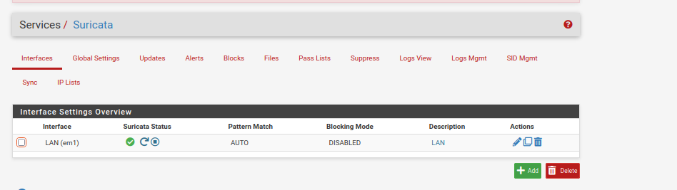

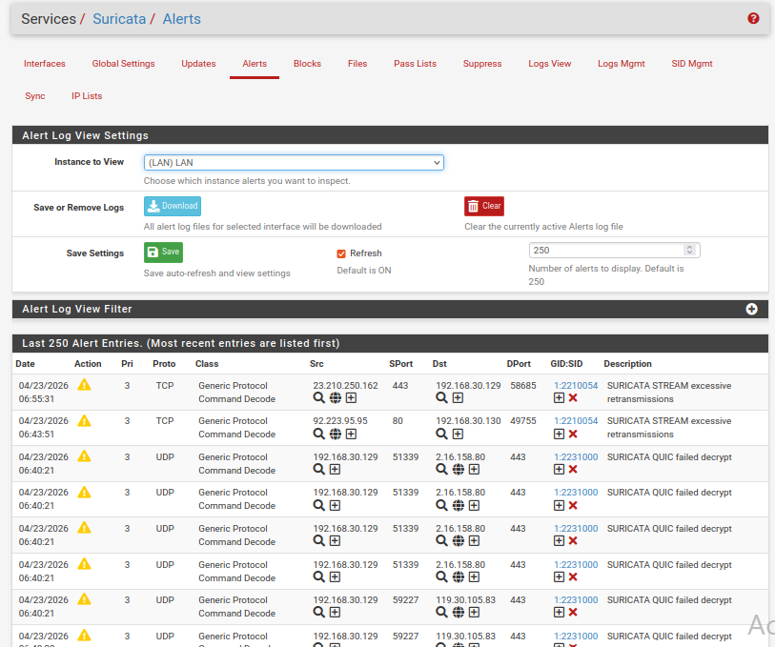

5.10. MISP Deployment & Custom Scenario Exploration
MISP was deployed on the Ubuntu 20.04 SOC VM for threat intelligence management and IOC sharing. Custom threat scenarios were created manually to explore the platform's IOC management, event structure, tagging, feed management, and MITRE ATT&CK; mapping workflows. MISP was deployed on the Ubuntu 20.04 SOC VM using Docker, via the harvard-itsecurity MISP Docker image. This method simplifies the complex MISP dependency stack into a containerized setup.

- Step 1 — System Update & Docker Install
sudo apt update && sudo apt upgrade -ysudo apt install -y docker.io docker-compose
- Step 2 — Clone MISP Docker Repository
git clone https://github.com/harvard-itsecurity/misp-docker.gitcd misp-docker
- Step 3 — Fix Permissions
sudo chown -R $USER:$USER ~/misp-dockersudo chmod -R 775 ~/misp-docker
- Step 4 — Configure Environment File
cp template.env .env
- Open .env file and set the MISP base URL:
MISP_BASEURL=http://192.168.10.X
Save changes.
- Step 5 — Pull & Start Container
docker compose pulldocker compose up -d
- Step 6 — Verify Container Running
docker ps -a# MISP container should show status: Up
Access MISP via browser: http://192.168.10.X
Default credentials: admin@admin.test / admin — change immediately after first login.

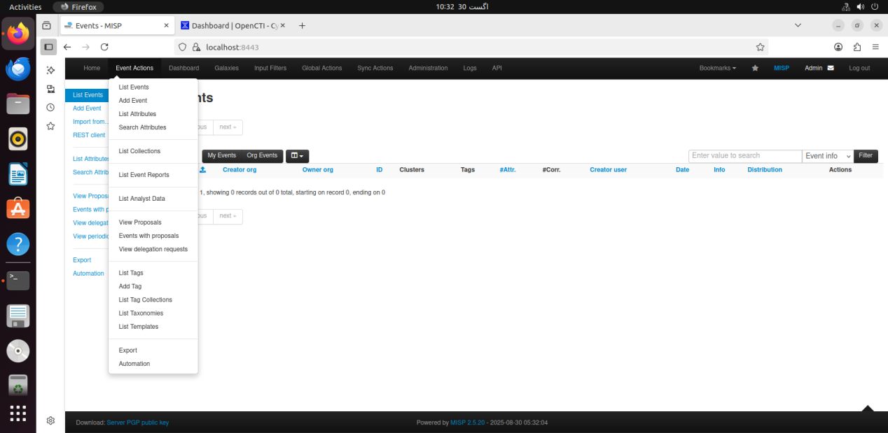
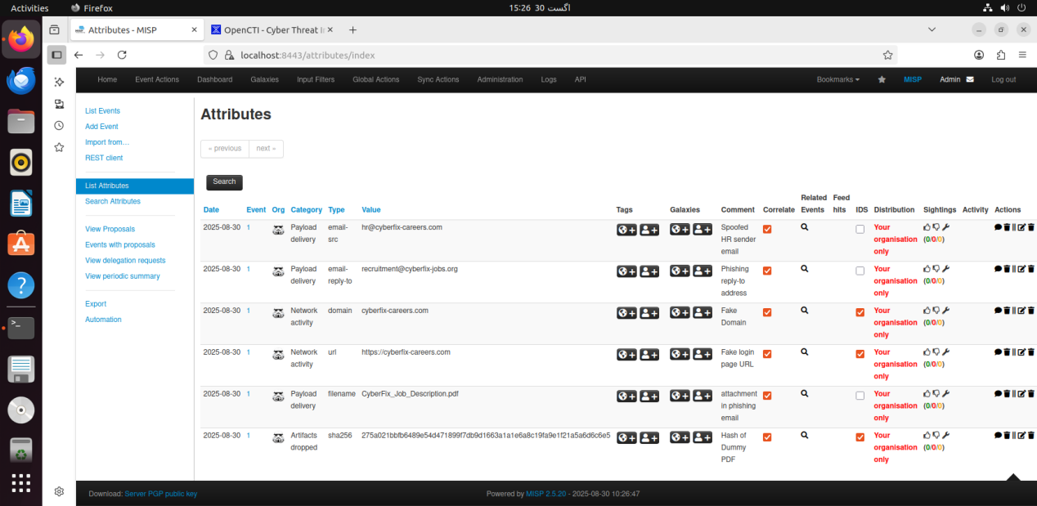

5.11. OpenCTI Deployment & MISP Integration
OpenCTI was deployed via Docker Compose on the same Ubuntu 20.04 SOC VM. After deployment, it was connected to MISP via the built-in MISP connector and the custom scenarios were explored through the OpenCTI interface.
Step 1 — Prerequisites
# Fix vm.max_map_count (required for ElasticSearch): sudo sysctl -w vm.max_map_count=262144
echo 'vm.max_map_count=262144' | sudo tee -a /etc/sysctl.conf

# Install Docker:
sudo apt install -y docker.io docker-compose sudo systemctl enable --now docker
sudo usermod -aG docker $USER && newgrp docker
Step 2 — Clone & Configure
git clone https://github.com/OpenCTI-Platform/docker.git opencti-docker cd opencti-docker && cp .env.sample .env
nano .env

OPENCTI_ADMIN_EMAIL=admin@soc.lab OPENCTI_ADMIN_PASSWORD=SecureLabPass123! OPENCTI_BASE_URL=http://192.168.10.X:8080 CONNECTOR_MISP_URL=https://192.168.10.X CONNECTOR_MISP_KEY=[MISP_API_KEY] CONNECTOR_MISP_SSL=false

Step 3 — Start & Verify
docker-compose up -d
docker-compose logs -f # monitor startup (5-8 min first run) docker-compose ps # all containers must show state: Up
Browser → http://192.168.10.X:8080
Data → Connectors → MISP connector → Status: Running Data → Indicators → MISP IOCs sync within ~2 minutes
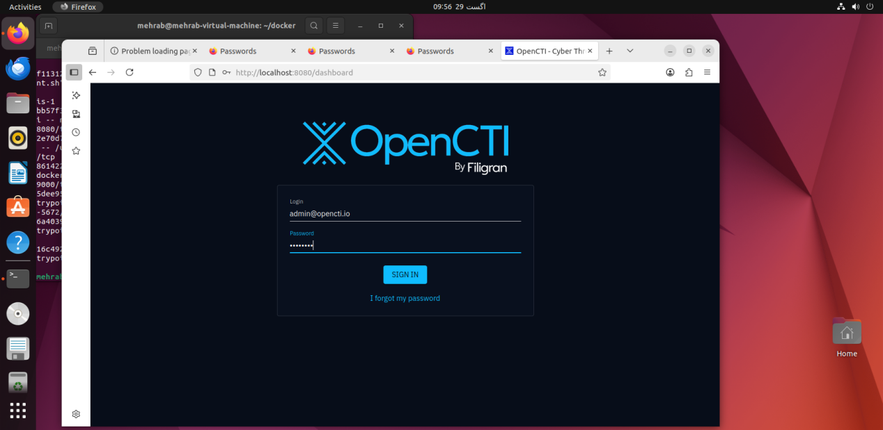
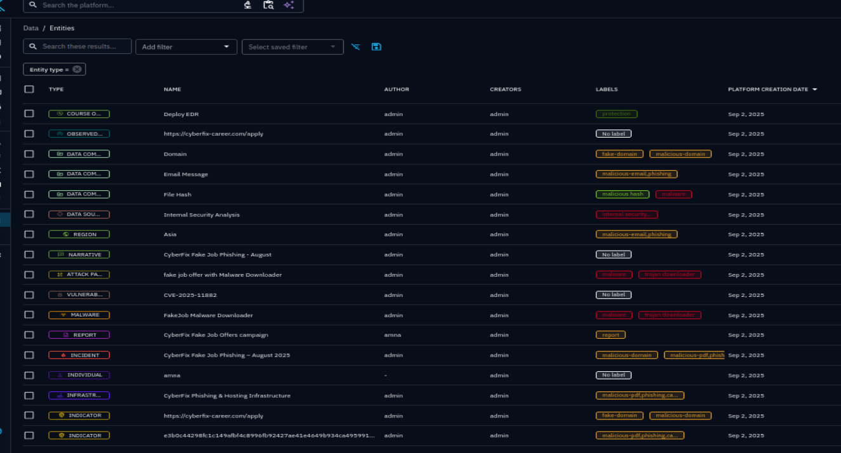
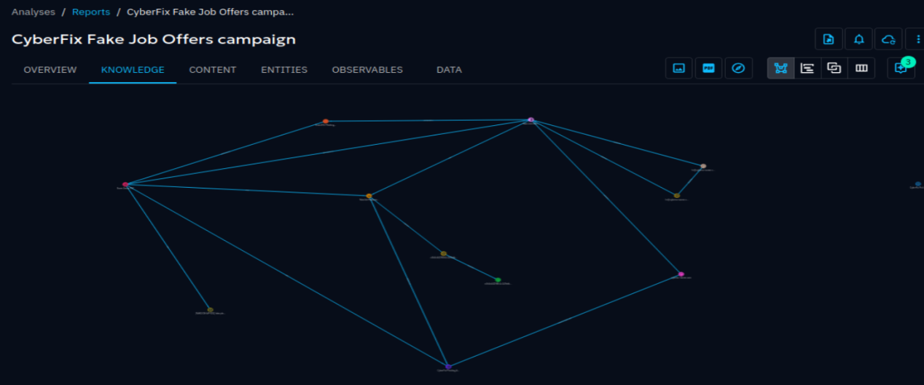

5.12. DVWA Deployment (Docker — Separate Ubuntu VM + Wazuh Agent)
DVWA was deployed on a dedicated Ubuntu 20.04 VM in the Attack subnet. This VM also had the Wazuh Agent installed and enrolled with the Wazuh Manager. No attacks were performed , this report covers deployment only.
NOTE: DVWA runs on a dedicated Ubuntu VM (192.168.30.20) in the Attack subnet — separate from Kali Linux (192.168.30.X). Both VMs share the same subnet but are independent machines.
Step 1 — Create VM & Install Ubuntu

    - Create VM: 1 vCPU, 1 GB RAM, 30 GB disk  VMnet4
    - Install Ubuntu Server 20.04 LTS > static IP: 192.168.30.X / 24, Gateway: 192.168.30.1

Step 2 — Deploy DVWA via Docker
sudo apt install -y docker.io && sudo systemctl enable --now docker

sudo docker run -d \
--name dvwa -p 80:80 --restart unless-stopped \ vulnerables/web-dvwa
# Initialize: Browser → http://192.168.30.X/setup.php
# Click: Create / Reset Database → Login: admin / password # DVWA Security → Security Level → Low → Submit
Step 3 — Install & Enroll Wazuh Agent
# Add Wazuh repository:
curl -s https://packages.wazuh.com/key/GPG-KEY-WAZUH | sudo apt-key add - echo 'deb https://packages.wazuh.com/4.x/apt/ stable main' \
| sudo tee /etc/apt/sources.list.d/wazuh.list
sudo apt update && sudo apt install -y wazuh-agent

# Set Manager IP in ossec.conf:
sudo nano /var/ossec/etc/ossec.conf # Find: MANAGER_IP
# Change to: 192.168.10.X

sudo systemctl enable wazuh-agent sudo systemctl start wazuh-agent
# Verify on Wazuh Manager:
sudo /var/ossec/bin/manage_agents -l
# Expected: ID: 002 Name: dvwa-ubuntu Status: Active

5.12. Kali Linux Deployment
IMPORTANT: Kali Linux was deployed and configured in the Attack subnet as part of the lab setup. No attacks were performed. Attack simulation is outside the scope of this deployment report.
Step 1 — Download & Import
    - Download Kali Linux VMware OVA from: https://www.kali.org/get-kali/#kali-virtual-machines
    - VMware > File > Open > select .ova > Import > Edit Settings > Network: VMnet4, RAM: 2 GB, vCPU: 2
Step 2 — Update & Set Static IP
# Default credentials: kali / kali
sudo apt update && sudo apt full-upgrade -y

address | 192.168.30.X
netmask | 255.255.255.0
gateway | 192.168.30.1

Step 3 — Connectivity Verification
sudo nano /etc/network/interfaces auto eth0
iface eth0 inet static
dns-nameservers 8.8.8.8

sudo systemctl restart networking
ping 192.168.30.1 # pfSense Attack gateway → Success ping 192.168.30.X # DVWA Ubuntu VM → Success
ping 192.168.10.X # Wazuh Server → Success

Integration Testing & Validation

After all components were deployed, end-to-end validation confirmed all log flows, detection pipelines, and tool integrations were functioning correctly.

Endpoint Log Flow — Windows 10
    - Opened cmd.exe on Windows 10 > Sysmon Event ID 1 (Process Creation) generated
    - Wazuh Dashboard > Agents > WINDOWS10-ENDPOINT > Security Events > event visible within 30 seconds
    - Generated 5 failed login attempts > Event ID 4625 > Wazuh rule fired > alert in dashboard

DVWA Ubuntu VM — Wazuh Agent
    - Wazuh Dashboard > Agents > dvwa-ubuntu > Status: Active
    - Linux system logs from DVWA VM appearing in Wazuh Security Events

Suricata IDS — Alert Generation
    - Inter-subnet connectivity tests generated traffic through pfSense
    - pfSense > Suricata > Alerts tab > network events detected and logged
    - Syslog alerts forwarded to Wazuh > appeared in Wazuh Dashboard

MISP — Custom Scenario Validation
    - 3 custom threat events created (phishing, C2, malware) — published successfully
    - IOC attributes added, TLP tags applied, ATT&CK; mapping confirmed
    - OSINT feed ingestion tested — indicators pulled successfully

OpenCTI — MISP Sync Validation
    - MISP Connector status: Running — custom events synced within ~2 minutes
    - Knowledge Graph confirmed relationships between IOCs and threat actors

Splunk Cloud — Sample Log Exploration
    - Sample logs ingested , SPL queries executed , dashboard panels created

Full Validation Summary

Component | Validation Performed | Result
pfSense Routing | All three subnets reachable through gateway | Pass
Suricata IDS | Network events detected, alerts forwarded to Wazuh | Pass
Wazuh Server | Dashboard accessible, rules firing, alerts visible | Pass

Component | Validation Performed | Result
Wazuh Agent (Win10) | Manually enrolled, Sysmon + Security events forwarded | Pass
Sysmon | Process creation and network events captured | Pass
Wazuh Agent (DVWA VM) | Enrolled via ossec.conf, system logs collected | Pass
DVWA | Accessible at port 80, database initialized | Pass
Kali Linux | Deployed, static IP set, inter-subnet connectivity | Pass
MISP | Custom IOC events created, tagged, published | Pass
OpenCTI | MISP intel synced, knowledge graph visualized | Pass
Splunk Cloud | Sample logs ingested, SPL queries run, dashboards built | Pass

